Logbook Page Window

B. Charles Sutton W1MCP, Jim Hargrave W5IFP and Aki Yoshida JA1NLX

1.0 GENERAL

The Logbook Page holds all the information pertaining to your individual QSOs.

One of the biggest changes in Logger32 is how it handles multiple operators. In prior versions of Logger, if you wanted to keep separate logs for separate callsigns you were required to have multiple logs. In Logger32, you can still have multiple logs, but you may not find it necessary. Tracking is based on setting the operator callsign for individual contacts as they are entered. You do not need to change the operator callsign with each QSO you enter, but you must change it for the first QSO entered with a different callsign. This allows you to maintain everything in one single log. Logger32 checks the operator of each QSO to determine if it should be included when generating statistical and award tracking information. You can also export the entire logbook or a portion based on a single operator.

You change the current operator callsign by right-clicking in the Logbook Entry window and selecting the "Change operator" menu item If you prefer to use different logs, you still have the option to create multiple logs as before. From the Logger32 Main menu, select the File | Change Logbook menu items. A dialog box will appear requesting additional information. You must supply a filename (which must be unique), and the path for storing the file. After switching logs, you must run a recalculation to reset the statistics files to match the current log. You can do this from the Logger32 Main menu by selecting the Tools | Database maintenance | Recalculate statistics menu items.

If you choose to maintain multiple log files, you can change them from the Logger32 Main menu by selecting the File | Change Logbook menu items.

Note: Because of the way tracking and stats are handled, you can only have one instance of a log name per computer. Just ensure each log has a different name.

2.0 LOGGER32 TRACKS THREE DIFFERENT QSL TYPES, PAPER, LoTW & eQSL

You are able to track QSLs that you have sent, received and those that have been verified for DXCC. When you right click on an entry in the Logbook Page window, Logger32 will highlight that QSO and open a menu list. Select the "Set/show award credits" menu item and this will open the Award Status dialog box, where you can check/set the appropriate status of the highlighted QSO. See Award Tracking topic for details.

Note: When viewing your Award Statistics, if you have selected "All QSL types" at the bottom of the chart, Logger32 treats these fields as one. A "Y" in any one of the three QSL Received fields will count that QSO as a confirmed contact. You can also select individual QSL status by changing the QSL filter.

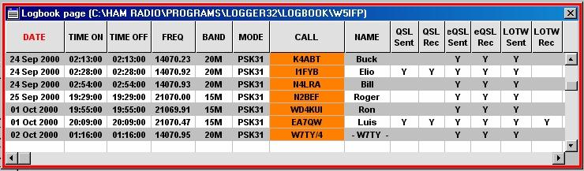

LBPW_1

3.0 LOGBOOK FIELD NAMES CAN BE CHANGED

When more than one word is used to define a field, the user can check the "Show Logbook Page Window column headers as Multi-line" check box. This will allow the names to fit in more narrow columns. If the column is made narrower, the words in the name will wrap to two or three lines depending on the name and column width.

Note: Header names with an underscore will not word wrap. As in the LBPW_1B example below. "QSL_SENT" is changed to two words "QSL Sent" By making the header two words the headers will now word wrap when Multi-line format is selected.

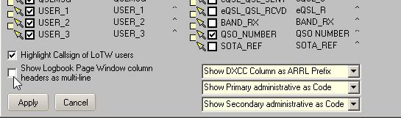

LBPW_1A

Below is an example of Multi-Line column headers:

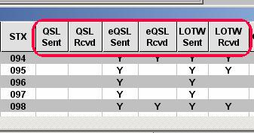

LBPW_1B

4.0 LOGBOOK COLUMNS CAN BE SORTED

By clicking on a column heading, Logger32 will display your QSOs in ascending order sorted on that column. When you select a column sort, that column's header will be displayed in red (Date column in the example above LBPW_1). When you select a column to sort, Logger32 will only display QSOs with data in the sorted field. For example, if you sort on IOTA, then only QSOs with an IOTA entry will be displayed.

Note: If you should sort on a field that does not contain data, Logger32 will display the following error message, cancel the sort request, and return you to the Logbook Page.

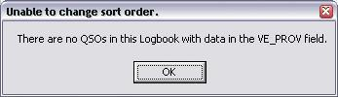

LBPW_2.

If you choose to display more fields than can be displayed in the window you will see a scrollbar at the bottom of the window. Once your log exceeds the number of lines that can be displayed in the window, you will notice a scrollbar on the right side of the window. The sort you have selected is maintained when scrolling through the logbook.

5.0 CHANGING LOGBOOK GRID APPEARANCE

You can change the appearance of the grid such as displaying the grid lines, changing the row height and column width, alternating grid background colors and much more. Refer to the Grid Appearance Setup topic for complete details.

6.0 SET QSO END TIME

This option will change the End Time of the highlighted QSO to match the current time.

7.0 MODIFYING QSO INFORMATION.

You can change the data in any cell by left-clicking in that cell and simply typing in the correct information. After you have made the change, you must save the change by one of the following actions:

  - <Tab> key - Saves the change and moves to the next cell. Remains in "edit" mode
  - <Enter> key - Saves the change and return focus to the Logbook Entry window.
  - <Up> or <Down> arrow keys - Saves the change and returns focus to the Logbook Entry window.
  - Mouse Pointer - Position the pointer in another cell and left-click. Remains in "edit" mode.

The following describes the use of additional keys and their action in the "Edit" mode:

  - <Esc> key - Edit is cancelled and the focus is moved back to the Logbook Entry window.
  - <Page Up> or <Page Down> keys - Edit is canceled and the Logbook is moved Up or Down one page. As you are no longer in "Edit" mode, further use of the arrows has no effect.
  - <Ctrl+End> and <Ctrl+Home> key combinations - Change the cell being edited to the rightmost or leftmost cell.
  - <Left> or <Right> arrow keys - Changes the cell being edited to the left or right.
Note: Some fields cannot be edited directly in the Logbook cells. Examples are: "COUNTRY" and "ADMIN SUBDIVISION". If you attempt to edit one of these fields, an error message will be displayed displaying the correct procedure for editing.

When entering QSOs from the Logbook Entry window or the Add QSO window, the mode field is limited to those modes defined in your BandMode table. However, you can change the mode field for any QSO in the Logbook Page window by left-clicking in the mode field and changing the text to any valid ADIF mode

8.0 QUICK EDIT

A right-click on any Logbook Page column header will open a Quick Edit dialog box. This dialog box allows you to make several changes to the columns and headers.

The left section allows the column headers to be moved, re-named and formatted. Clicking on the <Apply changes to this column> button will save the changes. You can also select the column to the left or right for further editing without closing the window.

The right section accommodates DXCC and Multi-line header selection. Clicking on the <Apply changes to this Form> button will save the appropriate changes.

The <Move this column to the left> (or right) buttons are dynamic and the change will be executed immediately.

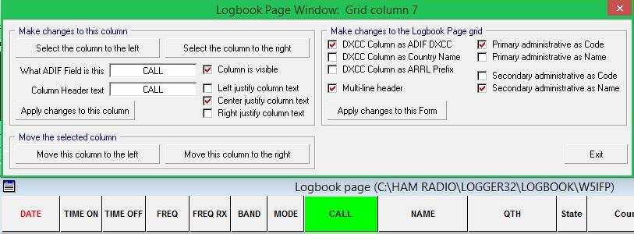

LBPW_2A

9.0 LOGBOOK OPTIONS

9.1 Setting up the Grid and Choosing the Fields to Display

When you right-click anywhere inside the Logbook Page window a pop-up menu will appear allowing you to modify the Grid. These changes will apply only to the Logbook Page window.

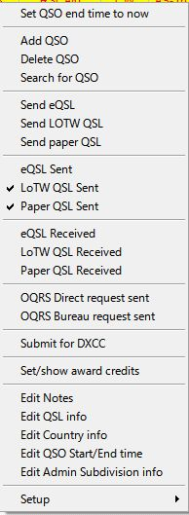

LBPW_3

9.2 Changing Cell Color

Choosing Cell text color (edit) and Cell background color (edit) will change the color of the cell you have chosen to edit. Notice QSO #1, the font color has changed to red and the cell background has changed to light blue.

9.3 Changing Column Header Names

Choosing the Grid layout will allow you to change the column header names, the justification of the columns and the order in which the columns are displayed. Please refer to the Grid Layout Setup topic for complete details.

10.0 ADDING OR DELETING A QSO

To add a QSO, right-click anywhere in the Logbook Page window and select Add QSO. The Add QSOs manually dialog box will be displayed.

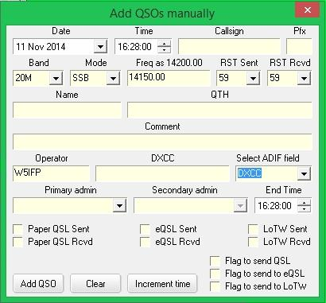

LBPW_5

Note: Logger32 determines the DXCC Country based on current callsign allocations. No adjustment to DXCC Country is made based on certain date ranges.

For example, in the 1970s many Russian and German callsigns were assigned differently than they are today. While this window is functional, if you have a large number of older QSOs to enter, you should probably use a program specifically written for the purpose (ask for advice on currently recommended software the Hamlogger reflector) that will create an ADIF file that can be imported into Logger32.

If you have just a few new records, you can change the ADIF field to DXCC as shown below and enter the correct DXCC based on the date of your QSO. If you leave this field blank, Logger32 will assign the most current designation based on the callsign prefix.

11.0 NAVIGATION

The following steps define the ways to navigate through the Logbook Page records. With the mouse pointer on the Logbook Page window and the grid showing QSOs. A Mouse-click on a row with QSO data will select that QSO:
  - Mouse left-click: The row is set for editing;
  - Mouse right-click: A menu of options is presented; and,
  - Mouse scroll: Moves through the logbook QSO by QSO. Holding down the <Shift> key, and rotating the mouse wheel, moves through the logbook a full page at a time.

The <Home>, <End>, <Page Up> and <Page Down> keys move the logbook as expected.

Arrow keys have no effect on the grid (It's a Microsoft thing).

11.1 Field Data

11.1.1 Date Field

This field will default to the current date. You can change the date by highlighting any of the three sections (month, day or year) and increase or decrease the field by using the <+> and <-> keys on the numeric pad or by using the <Up> and <Down> arrow keys. You can also select a date by clicking on the arrow to the right of the date and accessing the calendar.

11.1.2 Time Field

This field works very similar to the date field.

11.1.3 Band and Mode Fields

As you enter data here, you will notice the frequency will change to approximately the middle of that section of the band. The frequency can then be manually changed. If you enter a mode that has a submode associated (like SSTV), the submode field will become visible to the right of the End Time field.

Note: When entering the Mode, the drop-down list is populated with all of the valid ADIF modes, you are no longer restricted to those modes defined in the BandMode table.

11.1.4 Address and Select ADIF Fields

These fields operate together. When you change the Select ADIF Field, the name on the field immediately to its left will change to match your choice. This allows you access to every field in your logbook. As you change fields, any data you entered in a previous field is retained and will be added to your QSO entry.

11.1.5 Other Fields

Several fields are "sticky" in that they remember the last data entered. This should make adding several QSOs much easier, especially if there are several on the same day or band.

  - Placing a check in QSL Sent or QSL Rcvd will update the corresponding ADIF fields.

  - Placing a check in Flag QSO for QSL, eQSL or LOTW will flag the QSOs to be included in your next corresponding log export.

  - The <Clear> button will clear any data from the non-sticky fields.

The Exit window will close the Add QSOs manually dialog box. If there is data in the fields, it will not be logged.

If you try to enter a QSO with the same time as a QSO already in your logbook, a pop-up message will alert you. Select the <OK> button and either change the time or select the red <Increment time> button to the right of the <Clear> button. This will increment the time and log the QSO.

To delete a QSO, right-click in the appropriate row and select Delete QSO. A confirmation message will be displayed. Select the <Yes> button to delete the QSO or the <No> button if you made an error.

To search for a QSO, right-click anywhere within the Logbook Page window and select Search for QSO. A Search the Logbook dialog box will open and you can choose from many of the fields to conduct your search, some are shown here:

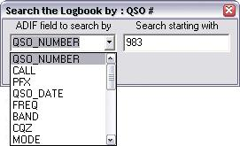

LBPW_6

Depending on what field you choose to search, the Logbook Page will react differently. For example, if you choose to search by QSO number beginning with 983 as in the image above, the log will sort by QSO number and then position itself at QSO #983. One thing to note is that when sorting, only QSOs with matching data will appear in the log. For example, if you sort by IOTA starting with NA-001, the log will first sort by IOTA, then position itself at NA-001 and only those QSOs with an IOTA entry will display in the log. Once you have selected your search criteria, you can move the Search the Logbook dialog box out of your way while you are working with the log. The Logbook Page and the Search dialog box interact and you can make changes to your search routine from either window.

Example: You can choose another sort routine by clicking on a header in the Logbook Page while leaving the QSO search dialog box open. A corresponding change will be reflected in the QSO Search dialog box.

Once you close the Search the Logbook dialog box, the Logbook Page reverts back to the condition it was in before you invoked the search.

12.0 FLAGGING QSO RECORDS

Right-clicking on any QSO will bring up Logbook Options menu (see LBPW_3 above) where in the center of the window are 4 options:

  - Send QSL - This option will flag the QSO so that it is included with the next QSL Record export;
  - Send eQSL - This option will flag the QSO so that it is included with the next eQSL Record export;
  - Send LoTW - This option will flag the QSO so that it is included with the next LoTW Record export; and,
  - QSL Sent - This option will set the field QSL_Sent to Yes.

13.0 HIGHLIGHTING THE STATUS OF QSO RECORDS

You can set-up different highlight colors to visually help identify the status of a QSO. Highlights include Worked, Confirmed, QSL sent, and QSLs flagged for printing.

  - eQSL Sent: Clicking on this option will set the eQSL Sent field to Yes.
  - LoTW QSL Sent: Clicking on this option will set the LoTW Sent field to Yes.
  - Paper QSL Sent: Clicking on this option will set the QSL Sent field to Yes and also add the current date to the QSL Sent Date field.
  - eQSL Received: Clicking on this option will set the eQSL Received field to Yes.
  - LoTW QSL Received: Clicking on this option will set the LoTW QSL Received field to Yes.
  - Paper QSL Received: Clicking on this option will set the QSL Received field to Yes and also add the current date to the QSL Received Date field.
  - eQSL Verified: Clicking on this option will set the eQSL Received field to Verified.LoTW QSL
Verified: Clicking on this option will set the LoTW QSL Received field to Verified.
  - Paper QSL Verified: Clicking on this option will set the QSL Received field to Verified.

14.0 EDIT NOTES

Any notes associated with the callsign will be displayed along with the QSO date. To enter a note for this particular QSO, type the information in the text box and choose the <Apply> button.

15.0 EDIT QSL INFO

The Edit QSL Info dialog box will appear as shown here:

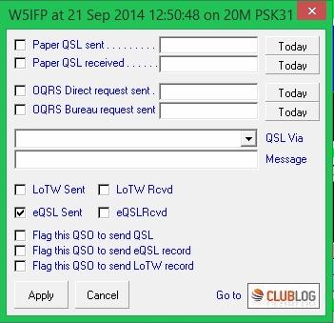

LBPW_4

You can change the data that is displayed, add a QSL manager (or bureau) or add a QSL message. The message section here will appear in the ADIF QSL_Message field. Many QSL printing programs will print any data entered in this field on your QSL card or label.

The QSL Via drop-down list includes the following options:

  - Bureau
  - Direct
  - OQRS direct request sent
  - OQRS bureau request sent
  - OQRS direct request received
  - OQRS bureau request received
  - Manager direct
  - Manager by bureau
  - QSL service
  - eMail request Auto QSL

You can either manually enter data in the field; choose an option from the drop-down box, or a combination of the two. For example, you could select "Manager direct - " from the drop-down box and then type in CA1LL after it.

The new auto-update of Logger32 attempts to provide easier and smoother access to OQRS (which is essentially a closed system). The Edit QSL Info dialog box has four new OQRS related options under the QSL_VIA drop down list. Also, clicking the Club Log logo will take you directly to the Club Log search page for the station you selected in the Logbook Page Window. There you can query your QSOs with the station, and by the click of a button, go to ClubLog's OQRS pages. If you have selected a QSO in your logbook with a station in your logbook that does not have logs at Club Log, you will be taken to the Club Log page that lists all on-line DXpedition logs.

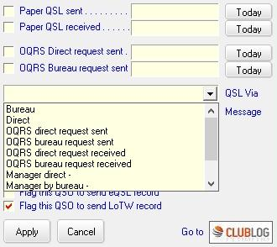

LBPW_4A

16.0 EDIT COUNTRY INFO

This option will display a grid, as shown below, and allow you to choose a different country for the QSO.

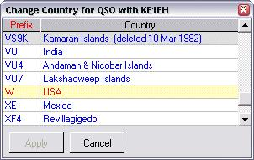

LBPW_8

17.0 EDIT QSO Start/End time

This option will display Edit QSO Start/End time window as shown below. If you wish then “End time=Start time” box may be checked.

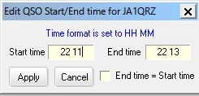

LBPW_8A

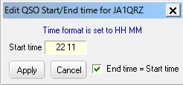

LBPW_8B

18.0 EDIT ADMIN SUBDIVIION INFO

This option will display a grid, as shown below, and allow you to choose a different Administrative Subdivision for the QSO.

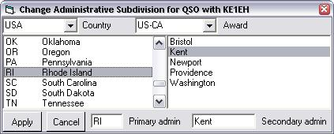

LBPW_9

19.0 SETUP

Right click on Logbook Page Window. Click Setup to show setup menu.

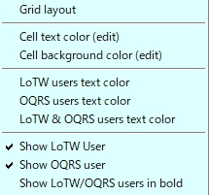

LBPW_9A

19.1 Grid Layout

Allows you to change the column header names, the justification of the columns and the order in which the columns are displayed. Refer to the Grid Layout Setup topic for complete details. Choosing cell text color (edit) and cell background color (edit) will change the color of the cell you have chosen to edit. Notice QSO #1, the font color has changed to red and the cell background has changed to light blue.

19.2 Cell text color (edit) and Cell background color (edit)

Allows to change text color and cell background color in edit mode.

19.3 LoTW users text color, OQRS users text color and LoTW & OQRS users text color

Allows to change text color for LoTW users, OQRS users and LoTW/OQRS users.

19.4 Show LoTW user, Show OQRS user and Show LoTW/OQRS users in bold

Allows to enable//disable to show each user in bold.

20.0 19.2 Deleting Logbooks

If you have any old or unwanted logbooks that you wish to delete you must first open Logger32 and then open a logbook you wish to keep. Finally, close Logger32.

Open Windows Explorer and browse to the Logger32 directory.Manually delete the four files associated with the logbook you wish to delete. The four files have the extensions: .isd, .isf, .isl and .ism. Note that if you close Logger32 with the logbook that you wish to delete in the open or active state, Logger32 will re-create that logbook the next time you start the program, although the new logbook will be blank with no logged entries.

21.0 20.0 ADIF Field Definitions

Note: the Logbook in Logger32 has one field for mode, however it is neither ADIF MODE nor ADIF SUBMODE field. Typical examples are shown below.

CW is one of the ADIF MODEs. If radio is in CW mode and “Mode from BandPlan” is checked then Logbook entry window shows “Mode CW” This QSO is logged in Logbook with mode=CW.

SSB is one of the ADIF MODEs. LSB and USB are ADIF SUBMODEs of the ADIF MODE SSB. If radio is in LSB mode and “Mode from BandPlan” is checked then the Logbook entry window shows “Mode SSB” This QSO is logged in Logbook with mode=SSB”

PSK is one of the ADIF MODEs. PSK31, PSK63 etc are ADIF SUBMODEs of the ADIF MODE PSK. If the radio is in the mode for PSK31 and “Mode from soundcard/CW machine” is checked then Logbook entry window shows “Submode PSK31” This QSO is logged in Logbook with mode=PSK31.

If you prefer to log this QSO with mode=PSK then “Mode from BandPlan” should be checked and
“Mode from soundcard/CW machine” should be unchecked.

RTTY is one of the ADIF MODEs. If the radio is the mode for RTTY then Logbook entry window shows “Mode RTTY” This QSO is logged in Logbook with mode=RTTY.

You may have different result depending on option checked in BandMode Selection table in Logbook entry window.

Below is a table of the ADIF fields used in your Logbook, along with the type of data, a description of the field's intended use, and any special features within Logger32.

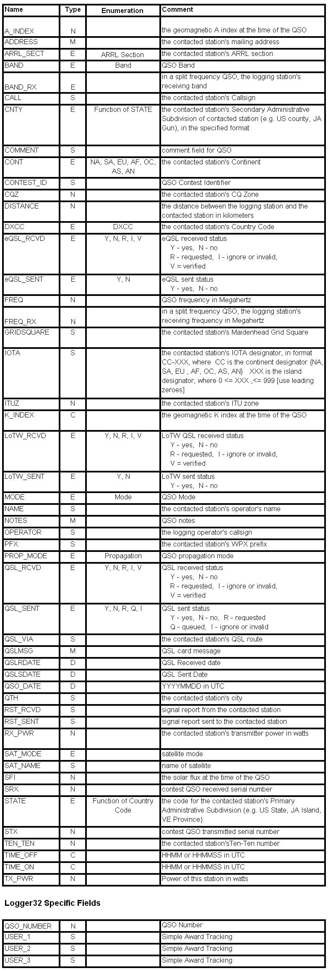

LBPW_7

